Module-III

Topics Page No

3.1 Sequential circuits 2

3.2 Introduction to flip flops 2

3.3 Latches 4

3.4 Edge Triggered flip flops 8

3.5 Race around condition 13

3.6. Master Slave flip flop 13

3.7 Asynchronous inputs of flip flop 14

3.8. Characteristics of flip flop 15

3.9 Realization of flip flops from other flip flops 16

3.10 Applications of Flip flops 17

3.11. Asynchronous Counters 19

3.11.4 Asynchronous Decade Counter 21

3.11.5 Asynchronous Up-Down Counters 22

3.12 Synchronous Counters 23

3.12.1 Synchronous Decade Counter 23

3.12.2 Synchronous Up-Down Counter 24

3.13 Procedure for design of Sequential Circuits 25

3.14 Applications 29

3.1 Sequential Circuits

The Logic circuits whose outputs, at any instant of time, depends not only the present input but also the past output called sequential circuits.

. 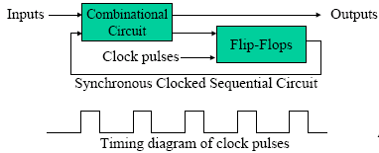
Sequential circuits are two types: Synchronous and Asynchronous.
In asynchronous circuits one event can occur after one event is compiled. No need of waiting clock pulses.
Synchronized circuits are circuits which produce output only when input coincides with arrival of clock pulses.
Synchronization is achieved by a timing device called master clock generator which generates a periodic clock.
The clock signal is generally some form of square wave is given below.
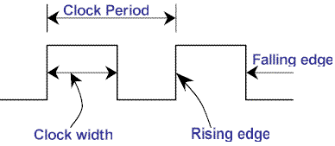

3.2 Introduction to Flip Flops
The basic logic element that provides memory in many sequential circuits is flip-flop. The flip-flop itself is a simple sequential circuit. It is seen that feedback is present in flip-flop circuits. Flip flop is the basic unit of storage. This is used to store one bit of information. Flip-flops are synchronous bi-stable devices. The term synchronous means the output changes state only when the clock input is triggered. That is, changes in the output occur in synchronization with the clock. It has two stable states 0 and 1.It has one or more inputs and two outputs. Two outputs are complementary. Flip flop output is remaining set/reset until the trigger pulse is given to change the state. It can be regarded as memory device.

The basic bi-stable element

The bi-stable element is central to all the flip-flops are shown below.

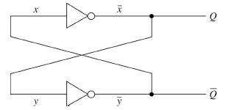
- The circuit consist of two cross coupled NOT Gates.
- It has two stable states.
- Q and ‾Q are two outputs complement of each other.
- The data stored 1 or 0 in basic bi-stable element is state of flip-flop.
- 1 – State is set condition for flip-flop.
- 0 – State is reset / clear for flip-flop.
- It stores 1 or 0 state as long power is ON.
To see the working of this circuit first assume x=0 in the above figure. The output of the upper NOT gate is 1 ie, Q=x’=1. Since the output of the upper NOT gate is the input of the lower NOT gate x’=y=1.The output of the lower NOT gate is y’=0. Thus the circuit is stable with two outputs Q=1 and Q’=0.
Using the similar argument, it is easy to show that if it is assumed that x=1, then also the bi-stable element is stable with outputs Q=0 and Q’=1.So this bi-stable device having two stable conditions and is used to store binary symbols. When the output Q=1, the element is said to be storing 1, when the output Q=0 the element is said to be storing 0.
This bi-stable element has no inputs. When the power is applied, it becomes stable in one of its stable states. It remains in this state until the power is removed. For the circuit to be useful, there is provisions must be made to force the device into a particular state. Flip-flop consists of this bi-stable element in which appropriate logic is added in order to control its state. The process of storing 1 into flip-flop is called setting or presetting the flip-flop. The process of storing 0 into a flip-flop is called resetting or clearing the flip-flop.
Mainly the flip-flops are divided into three categories.
Latches, Edge triggered flip-flops, and Pulse triggered flip-flops.

3.3 Latches
This is one class of flip-flop. In this device output change is not controlled. That is, the output essentially responds immediately to changes on the input lines, although a special control signal, called the enable or clock might also be present.
3.3.1 S-R latch
The Set-Reset latch, commonly called S-R latch, has two inputs (S and R), one true output (Q) and one complemented output (Q’) as shown in Figure. The crossing of the outputs is known as cross coupling and this circuit is said to employ cross-coupled feed back. When the output at Q is HIGH (1) the latch is said to be in the set state, similarly when Q = 0 the latch is said to be in the clear (or Reset) state.

3.3.1.1 NOR gate realization of SR Latch
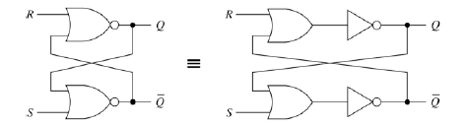
SR Latch has two useful states:
- Set state, when output Q=1 and Q’=0
- Reset state, when output Q=0 and Q’=1.
These states to can be used to store 1-bit information. Output Q and Q’ are normally complement of each other.
- Undefined state, when Q=0 and Q’=0, occurred when both inputs R and S are equal to 1 at the same time.

- Under normal conditions, both inputs of the latch (Rand S) remain at 0 unless the state has to be changed.
- To let latch in the set state, S must be 1
- To let latch in the reset state, R must be 1
- The inputs S and R must go back to 0 before any other changes to avoid the occurrence of the undefined state.
The latch goes to the set state or reset state and stays there even after both inputs return to 0.

The logic symbol and the corresponding truth table for the S-R latch are presented in the following Figures.
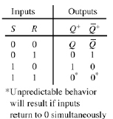
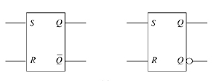
3.3.1.2 NAND gate realization of S R Latch
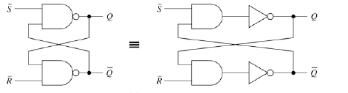
- Set state, when output Q=1 and Q’=0.
- Reset state, when output Q=0 and Q’=1.
- Output Q and Q’ are normally complement of each other.
- Undefined state, when Q=1 and Q’=1, occurred when both inputs R and S are equal to 0 at the same time.

- Under normal conditions, both inputs of the latch (Rand S) remain at 1 unless the state has to be changed.
- To let latch in the set state, S must be 0
- To let latch in the reset state, R must be 0
- The inputs Sand R must go back to 1 before any other changes to avoid the occurrence of the undefined state (when Q=1 and Q’=1)
- The latch goes to the set state or reset state and stays there even after both inputs return to 1.
The logic symbol and the corresponding truth table are in the following Figures.
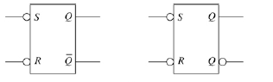

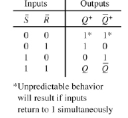

3.3.1.3 Gated SR latch
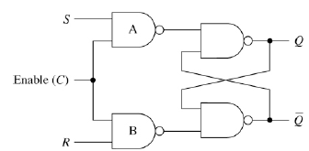
- Enable input C is clock input.
- C=1, Output changes as per input condition.
- C=0, No change of state.
- S=1, R=0 is set condition for Flip-flop.
- S=0, R=1 is reset condition for Flip-flop.
- S=R=1 is ambiguous state, not allowed

The logic symbol and the corresponding truth table for the Gated S-R latch are presented in the following Figures.
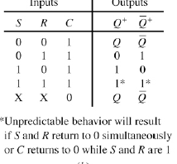
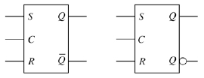

3.3.2 Gated D latch

The gated D latch is gated SR latch which is not-gate is connected between the S and R terminals. Thus this latch consists of a single input called D that determines the next state and control ie, enable, input C that determines when D input effective. As indicated in the function table, when the latch is enabled ie, C=1, the output of the latch follows the values applied to the D input terminal. If D=0, then the latch switches to or remains in the 0-state, while if D=1, then the latch switches to or remains the 1-state. The circuit and truth table is given below.
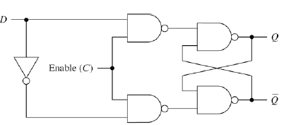

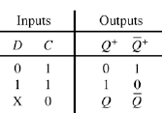
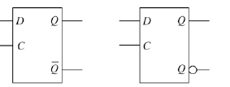

- D Flip-Flop is Data Flip-Flop.
- D Flip-Flop stores 1 or 0.
- R input is complement of S.
- Only one D input is present.
- D Flip-Flop is a storage device used in register.

3.4 Edge-Triggered Flip-flops
The main difference between latches and flip-flops is the method used to change their states. Latches are level sensitive, or level-triggered. This means that the outputs are dependent on the voltage level applied, not on any signal transition. An edge-triggered flip-flop changes states either at the positive edge (rising edge) or at the negative edge (falling edge) of the clock pulse on the control input. The three basic types are introduced here: S-R, J-K and D.

3.4.1 Edge-triggered S-R flip-flop
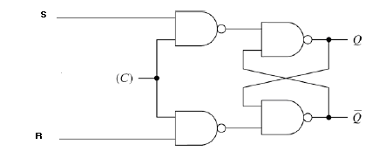

Basic Symbol
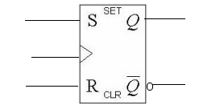
Small triangle, called the dynamic input indicator, is used to identify an edge-triggered flip-flop.
As S = 1, R = 0. Flip-flop SETS on the rising clock edge.
S== 0, R = 1. Flip-flop RESETS on the rising clock edge.
S=0,R=0. Flip-Flop state remains unchanged.

Truth Table of SR flip flop is given below.
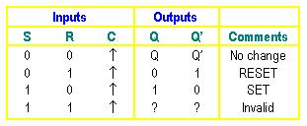
Note that the S and R inputs can be changed at any time when the clock input is LOW or HIGH (except for a very short interval around the triggering transition of the clock) without affecting the output.

Timing Diagram

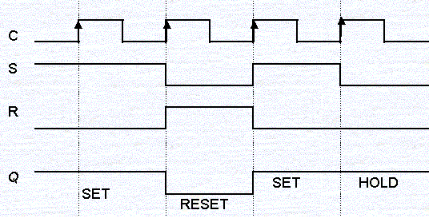
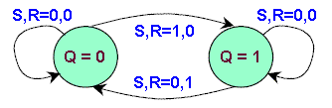
State Transition Diagram of SR flip-flop
3.4.2 Edge-triggered D flip-flop
D latch has only two inputs D (data) and C (control).
The operation of a D flip-flop is much simpler. It has only one input addition to the clock. It is very useful when a single data bit (0 or 1) is to be stored. If there is a HIGH on the D input when a clock pulse is applied, the flip-flop SET and stores a 1. If there is a LOW on the D input when a clock pulse is applied, the flip-flop RESET and stores a 0.
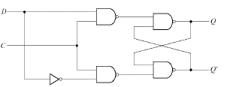
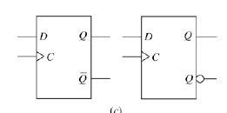
Truth Table
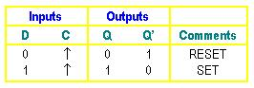
The negative edge-triggered flip-flop works the same except that the falling edge of the clock pulse is the triggering edge.

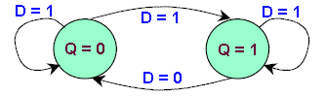
State Transition Diagram

3.4.3 Edge-triggered J-K flip-flop
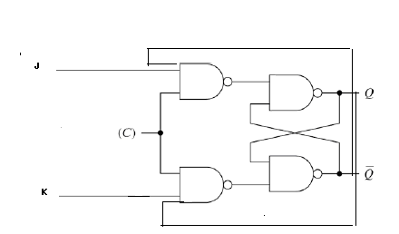
Basic symbol
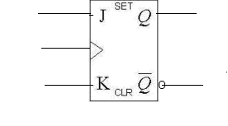
The JK flip-flop has the following characteristics:
- If one input (J or K) is at logic 0, and the other is at logic 1, then the output is set or reset (by J and K respectively), just like the RS flip-flop,
- If both inputs are 0, then it remains in the same state as it was before the clock pulse occurred; again like the RS flip flop.
- If both inputs are high, however the flip-flop changes state whenever the edge of a clock pulse occurs; i.e., the clock pulse toggles the flip-flop.
Truth Table and timing diagram is given below.
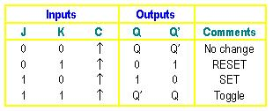
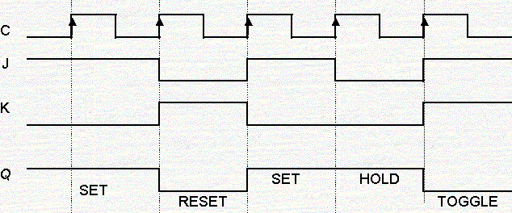
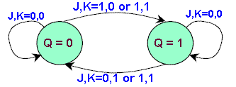
State Transition Diagram

3.4.4 T Flip Flop
The toggle, or T, flip-flop is a bi stable device that changes state on command from a common input terminal.
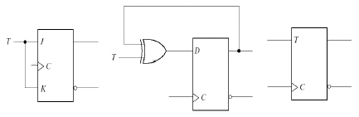

Truth Table

T | CLK | Q | Q’
0 | 1 | Q_{n} | Q_{n}’
1 | 1 | Q_{n}’ | Qn
X | 0 | Nochange
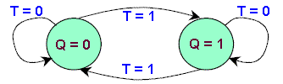
State Transition Diagram

3.5 Race- around condition

Consider the inputs of JK flip flop j=1 and k=1 and Q=0. When a clock pulse of width t_{p} is applied, the output will change from 0 to 1 after a time interval ∆t, where ∆tis the propagation delay of flip flop. After another ∆t output Q will become 0. Hence the output oscillates back and forth between 0 and 1 in duration t_{p} of the clock pulse width. So at the end of the clock pulse, the value of Q is ambiguous. This situation is called race around condition. The race around condition can be avoided if t_{p}<∆t. This can be avoided by using Master slave flip flop.

3.6 Pulse-Triggered (Master-Slave) Flip-flops
The term pulse-triggered means that data are entered into the flip-flop on the rising edge of the clock pulse, but the output does not reflect the input state until the falling edge of the clock pulse. As this kind of flip-flops are sensitive to any change of the input levels during the clock pulse is still HIGH, the inputs must be set up prior to the clock pulse's rising edge and must not be changed before the falling edge. Otherwise, ambiguous results will happen.

The three basic types of pulse-triggered flip-flops are S-R, J-K and D.

These flip-flops are also called Master-Slave flip-flops simply because their internal construction is divided into two sections. The slave section is basically the same as the master section except that it is clocked on the inverted clock pulse and is controlled by the outputs of the master section rather than by the external inputs.

3.6.1 Master-slave S-R flip-flop

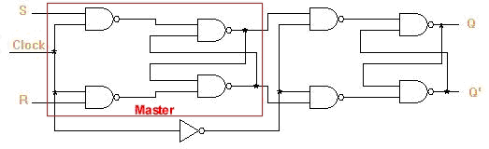
Logic symbol

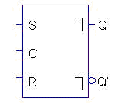

3.6.2 Master slave J-K flip flop

This consists of two RS flip flops arranged so that when the clock pulse enables the first, or master, latch, it disables the second, or slave, latch. When the clock changes state again (i.e., on its falling edge) the output of the master latch is transferred to the slave latch. Again, toggling is accomplished by the connection of the output with the input AND gates
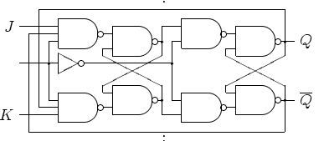
Logic Symbol
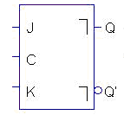

The JK flip-flop is a very versatile device, and is probably the most commonly used flip-flop in digital electronic and control circuits.

3.7 Flip Flops - With asynchronous inputs
The flip-flops discussed so far are called synchronous because the transfer of the data from the input to the output lines are synchronized with the triggering edge of the clock pulse. The S-R, J-K and D inputs in these flip-flops are called synchronous inputs. Most integrated circuit flip-flops also have asynchronous inputs that affect state of the flip-flop independent of the clock these are normally named direct set (PRESET) and clear (CLR). For the synchronous operations to work properly, these asynchronous inputs must both be kept LOW.
The logic symbol and the operation of a positive edge triggered J-K flip-flop with active LOW preset () and clear () inputs are shown in the following Figure. Note that we assume that Q is HIGH initially.

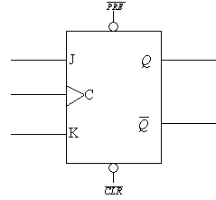

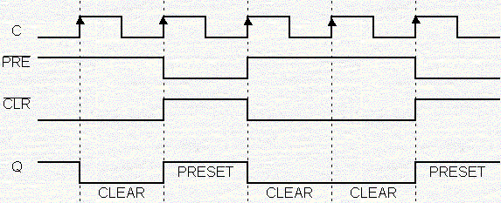

3.8 Operating Characteristics of flip-flops.

a) Propagation Delay Time - is the interval of time required after an input signal has been applied for the resulting output change to occur.

b) Set-Up Time - is the minimum interval required for the logic levels to be maintained constantly on the inputs (J and K, or S and R, or D) prior to the triggering edge of the clock pulse in order for the levels to be reliably clocked into the flip-flop.

c) Hold Time - is the minimum interval required for the logic levels to remain on the inputs after the triggering edge of the clock pulse in order for the levels to be reliably clocked into the flip-flop.

d) Maximum Clock Frequency - is the highest rate that a flip-flop can be reliably triggered.

e) Power Dissipation - is the total power consumption of the device.

f) Pulse Widths - are the minimum pulse widths specified by the manufacturer for the Clock, SET and CLEAR inputs.

3.9 Realization of a flip flop using other flip flops

It is possible to implement a flip flop circuit using any other circuit.

General block diagram is shown below.
A
Next state
decoder
C Q
FF-Y

D Q’

B

To realize a flip flop X using another flip flop Y along with a combinational circuit called next state decoder, is used which functions like flip flop X. A & B are the inputs of flip flop X and C ,D are the inputs of Y called next sate code. We have to find the inputs of Y.

The design procedure as follows.
- Obtain the clear description of the desired flip flop X.
- Obtain the present state- next state table for the desired flip flop.
- Using the excitation table of the chosen flip flop Y append the next state code to the above tale.
- Using K map simplify the logical expression for the excitation inputs of flip flop Y.
- Draw the circuit for the desired flip flop X.

Example: Realization of J K flip flop using SR flip-flop.

Next state Present state table for JK flip flop
Q_{n} | J | K | Q_{n+1}
0  0  0  0  1  1  1  1 | 0  0  1  1  0  0  1  1 | 0  1  0  1  0  1  0  1 | 0  0  1  1  1  0  1  0

Excitation Table for S R flip- flop

S | R | Q_{n+1}
0  0  1  1 | 0  1  0  1 | Q_{n}  0  1  ?

Append Excitation table to the table 1.
Q_{n} | J | K | Q_{n+1} | _{Excitation Inputs}
 |  |  |  | _{S} | _{R}
0  0  0  0  1  1  1  1 | 0  0  1  1  0  0  1  1 | 0  1  0  1  0  1  0  1 | 0  0  1  1  1  0  1  0 | 0  0  1  1  X  0  X  0 | X  X  0  0  0  1  0  1

Form the above table S= J Q_{n}’ and R= K Q_{n}

Q
S Q

R Q’

R
J

K Q’

3.10 Applications of Flip flops

3.10.1 Frequency Division
When a pulse waveform is applied to the clock input of a J-K flip-flop that is connected to toggle, the Q output is a square wave with half the frequency of the clock input. If more flip-flops are connected together as shown in the figure below, further division of the clock frequency can be achieved.

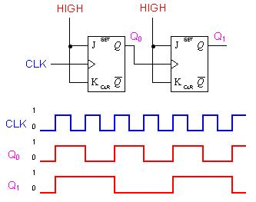

The Q output of the second flip-flop is one-fourth the frequency of the original clock input. This is because the frequency of the clock is divided by 2 by the first flip-flop, and then divided by 2 again by the second flip-flop. If more flip-flops are connected this way, the frequency division would be 2^{n}, where n is the number of flip-flops.

3.10.2 Parallel Data Storage
In digital systems, data are normally stored in groups of bits that represent numbers, codes, or other information. So, it is common to take several bits of data on parallel lines and store them simultaneously in a group of flip-flops.
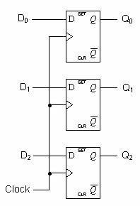
Each of the three parallel data lines is connected to the D input of a flip-flop. Since the same clock pulse is connected to the clock inputs of all the flip-flops, the data on the D inputs are stored simultaneously by the flip-flops on the positive edge of the clock.

3.10.3 Registers: Group of flip-flops use for data storage.

3.10.4 Counting: Group of flip-flops used as digital counters.

Counters
Counter is a sequential circuit which consists of a set of flip flops connected in a suitable manner to count the sequence of input pulses.
Counters are classified into two classes: Asynchronous and synchronous counters.

3.11 Asynchronous (Ripple) Counters

The external clock is connected to the clock input of the first flip-flop (FF0) only. So, FF0 changes state at the falling edge of each clock pulse, but FF1 (2nd flip flop) changes only when triggered by the falling edge of the Q output of FF0. Because of the inherent propagation delay through a flip-flop, the transition of the input clock pulse and a transition of the Q output of FF0 can never occur at exactly the same time. Therefore, the flip-flops cannot be triggered simultaneously, producing an asynchronous operation.

3.11.1 A two-bit asynchronous counter

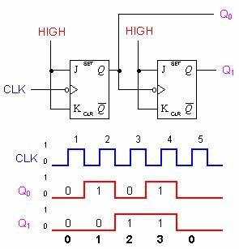

3.11.2 Three-bit asynchronous binary counter

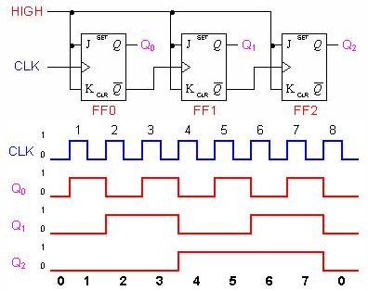

The clock pulse fed into FF0 is rippled through the other counters after propagation delays, like a ripple on water, hence the name Ripple Counter.
The 2-bit ripple counter circuit above has four different states, each one corresponding to a count value. Similarly, a counter with n flip-flops can have 2^{n} states. The number of states in a counter is known as its mod (modulo) number. Thus a 2-bit counter is a mod-4 counter.
A mod-n counter may also describe as a divide-by-n counter. This is because the most significant flip-flop (the furthest flip-flop from the original clock pulse) produces one pulse for every n pulses at the clock input of the least significant flip-flop (the one triggers by the clock pulse).
3.11.3 Binary Counting

Binary counter can be constructed from J-K flip-flops by taking the output of one cell to the clock input of the next. The J and K inputs of each flip-flop are set to 1 to produce a toggle at each cycle of the clock input. For each two toggles of the first cell, a toggle is produced in the second cell, and so on down to the fourth cell. This produces a binary number equal to the number of cycles of the input clock signal. This device is sometimes called a "ripple through" counter. The same device is useful as a frequency divider
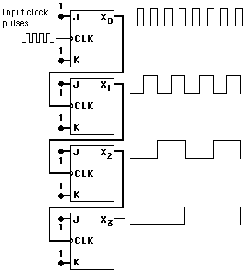

3.11.4 Asynchronous Decade Counter
The binary counters previously introduced have two to the power n states. But counters with states less than this number are also possible. They are designed to have the number of states in their sequences, which are called truncated sequences. These sequences are achieved by forcing the counter to recycle before going through all of its normal states.
A common modulus for counters with truncated sequences is ten. A counter with ten states in its sequence is called a decade counter (mod-10 counter).
By terminating the "ripple-through" counting when the count reaches decimal 9 (binary 1001). Since the next toggle would set the two most significant bits, a NAND gate tied from those two outputs to the asynchronous clear line will start the count over after 9.

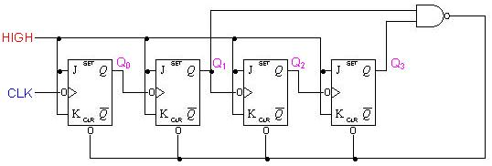
Once the counter counts to ten (1010), all the flip-flops are being cleared. Notice that only Q1 and Q3 are used to decode the count of ten. This is called partial decoding, as none of the other states (zero to nine) have both Q1 and Q3 HIGH at the same time.
The sequence of the decade counter is shown in the table below:
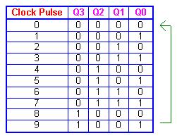

3.11.5 Asynchronous Up-Down Counters
In certain applications a counter must be able to count both up and down. The circuit below is a 3-bit up-down counter. It counts up or down depending on the status of the control signals UP and DOWN. When the UP input is at 1 and the DOWN input is at 0, the NAND network between FF0 and FF1 will gate the non-inverted output (Q) of FF0 into the clock input of FF1. Similarly, Q of FF1 will be gated through the other NAND network into the clock input of FF2. Thus the counter will count up.

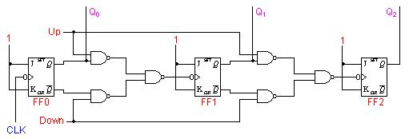

When the control input UP is at 0 and DOWN is at 1, the inverted outputs of FF0 and FF1 are gated into the clock inputs of FF1 and FF2 respectively. If the flip-flops are initially reset to 0's, then the counter will go through the following sequence as input pulses are applied.

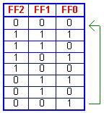

3.12 Synchronous Counters
In synchronous counters, the clock inputs of all the flip-flops are connected together and are triggered by the input pulses. Thus, all the flip-flops change state simultaneously (in parallel). The circuit below is a 3-bit synchronous counter. The J and K inputs of FF0 are connected to HIGH. FF1 has its J and K inputs connected to the output of FF0, and the J and K inputs of FF2 are connected to the output of an AND gate that is fed by the outputs of FF0 and FF1. A 3 bit synchronous counter is given below.

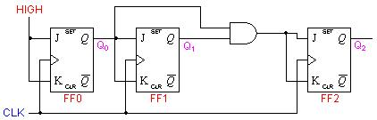

The most important advantage of synchronous counters is that there is no cumulative time delay because all flip-flops are triggered in parallel. Thus, the maximum operating frequency for this counter will be significantly higher than for the corresponding ripple counter
.

3.12.1 Synchronous Decade Counters

Similar to an asynchronous decade counter, a synchronous decade counter counts from 0 to 9 and then recycles to 0 again. This is done by forcing the 1010 state back to the 0000 state. The sequence of decade counter is given below.

- Q0 toggles on each clock pulse.
- Q1 changes on the next clock pulse each time Q0=1 and Q3=0.
- Q2 changes on the next clock pulse each time Q0=Q1=1.
- Q3 changes on the next clock pulse each time Q0=1, Q1=1 and Q2=1 (count 7), or when Q0=1 and Q3=1 (count 9)
The circuit diagram is shown below.

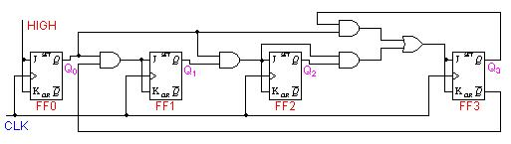

3.12.2 Synchronous Up-Down Counters
A circuit of a 3-bit synchronous up-down counter and a table of its sequence are shown below. Similar to an asynchronous up-down counter,
a synchronous up-down counter also has an up-down control input. It is used to control the direction of the counter through a certain sequence.
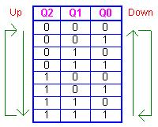

- for both the UP and DOWN sequences, Q0 toggles on each clock pulse.
- for the UP sequence, Q1 changes state on the next clock pulse when Q0=1.
- for the DOWN sequence, Q1 changes state on the next clock pulse when Q0=0.
- for the UP sequence, Q2 changes state on the next clock pulse when Q0=Q1=1.
- for the DOWN sequence, Q2 changes state on the next clock pulse when Q0=Q1=0.

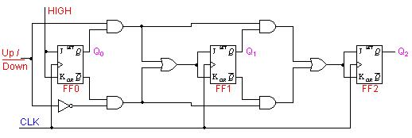

3.13 Procedure for design of Sequential Circuits

The design of a synchronous sequential circuit starts from a set of specifications and culminates in a logic diagram or a list of Boolean functions from which a logic diagram can be obtained. In contrast to a combinational logic, which is fully specified by a truth table, a sequential circuit requires a state table for its specification. The first step in the design of sequential circuits is to obtain a state table or an equivalence representation, such as a state diagram.
A synchronous sequential circuit is made up of flip-flops and combinational gates. The design of the circuit consists of choosing the flip-flops and then finding the combinational structure which, together with the flip-flops, produces a circuit that fulfils the required specifications. The number of flip-flops is determined from the number of states needed in the circuit.
Steps for the design of sequential circuits are given below
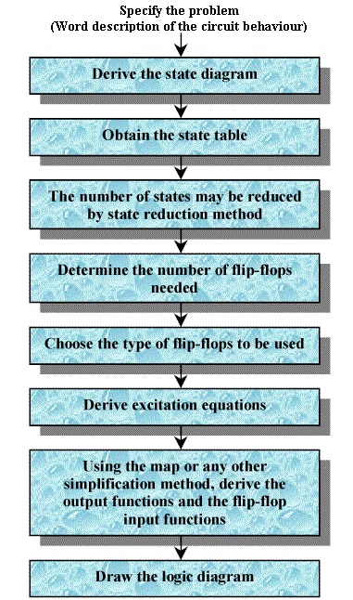

Example: Design a synchronous sequential circuit using J K flip flop whose state diagram is given

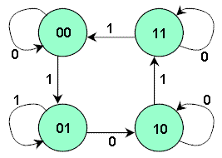

From the state diagram, we can generate the state table
Present State | Next state
Q0 Q1 | X=0 | X=1
0 0 | 0 0 | 0 1
0 1 | 1 0 | 0 1
1 0 | 1 0 | 1 1
1 1 | 1 1 | 0 0

Excitation table for JK flip-flop
Output Transitions | Flip-flop inputs
Q →Q(next) | J K
0 → 0 | 0 X
0 → 1 | 1 X
1 → 0 | X 1
1 → 1 | X 0

Excitation table of the circuit
Present State | Next State | Input | Flip-flop Inputs
  Q0 Q1
  Q0 Q1
  x
  J0K0 | J1K1
  0 0
  0 0
  0 1
  0 1
  1 0
  1 0
  1 1
  1 1
  0 0
  0 1
  1 0
  0 1
  1 0
  1 1
  1 1
  0 0
  0
  1
  0
  1
  0
  1
  0
  1
  0 X | 0 X
  0 X | 1 X
  1 X | X 1
  0 X | X 0
  X 0 | 0 X
  X 0 | 1 X
  X 0 | X 0
  X 1 | X 1

In the first row of Table we have a transition for flip-flop Q0 from 0 in the present state to 0 in the next state. In Table 10 we find that a transition of states from 0 to 0 requires that input J = 0 and input K = X. So 0 and X are copied in the first row under J0 and K0 respectively. Since the first row also shows a transition for the flip-flop Q1 from 0 in the present state to 0 in the next state, 0 and X are copied in the first row under J1 and K1. This process is continued for each row of the table and for each flip-flop.

The simplified Boolean functions for the combinational circuit can now be derived. The input variables are Q0, Q1, and x; the output is the variables J0, K0, J1 and K1. The information from the truth table is plotted on the Karnaugh maps.
The flip-flop input functions are derived
J0 = Q1.x' K0 = Q1.x
J1 = x K1 = Q0'.x' + Q0.x = Q0(XNOR )X

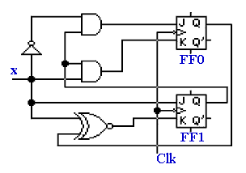

Example 2: Design a counter whose state diagram is given below, using T flip flop
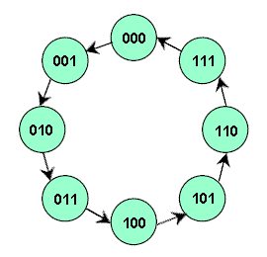
Excitation table.
Output State Transitions |  | Flip-flop inputs
  T2 T1 T0
Present State | Next State
  Q2 Q1 Q0
  Q2 Q1 Q0
  0 0 0
  0 0 1
  0 1 0
  0 1 1
  1 0 0
  1 0 1
  1 1 0
  1 1 1
  0 0 1
  0 1 0
  0 1 1
  1 0 0
  1 0 1
  1 1 0
  1 1 1
  0 0 0
  0 0 1
  0 1 1
  0 0 1
  1 1 1
  0 0 1
  0 1 1
  0 0 1
  1 1 1

Next step is to transfer the flip-flop input functions to Karnaugh maps to derive a simplified Boolean expressions,
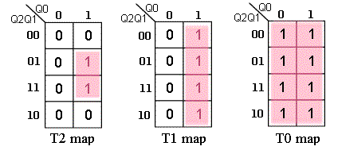
The following expressions are obtained

T0 = 1; T1 = Q0; T2 = Q1.Q0

Circuit Diagram
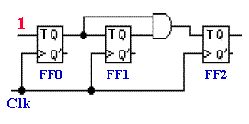

3.14 Applications

Digital counters are very useful in many applications. They can be easily found in digital clocks and parallel-to-serial data conversion (multiplexing). A group of bits appearing simultaneously on parallel lines is called parallel data. A group of bits appearing on a single line in a time sequence is called serial data.

3.14.1 Frequency Division
A frequency divider can be constructed from J-K flip-flops by taking the output of one cell to the clock input of the next. The J and K inputs of each flip-flop are set to 1 to produce a toggle at each cycle of the clock input. For each two toggles of the first cell, a toggle is produced in the second cell, so its output is at half the frequency of the first. The output of the fourth cell is 1/16 the clock frequency. The same device is useful as a binary counter.

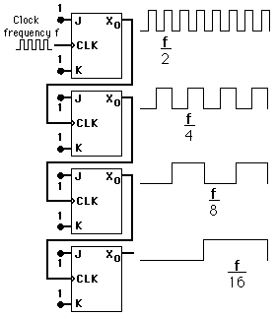

3.14.2 Parallel-to-serial conversion is normally accomplished by the use of a counter to provide a binary sequence for the data-select inputs of a multiplexer, as illustrated in the circuit.

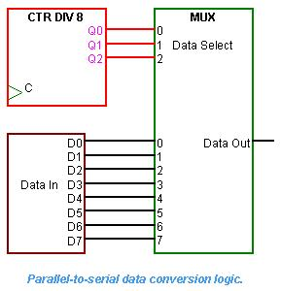

The Q outputs of the modulus-8 counter are connected to the data-select inputs of an eight-bit multiplexer. The first byte (eight-bit group) of parallel data is applied to the multiplexer inputs. As the counter goes through a binary sequence from 0 to 7, each bit beginning with D0, is sequentially selected and passed through the multiplexer to the output line.

After eight clock pulses, the data byte has been converted to a serial format and sent out on the transmission line. Then, the counter recycles back to 0 and converts another parallel byte sequentially again by the same process.

